**Group 2: Industrial Robots in Harsh Conditions Project Report**

Rock Bolt Assembling Robot

ROBO.666 Robotics Project Work, 2024

Date: 5 FEB 2025

|  |  |
| --- | --- |
| 151873018 | Kin Tung |
| 151785423 | Eren Pekgöz |
| 151790984 | Daniel Pedraglio O'Hara |

**Content**

1. Introduction 3

2. Requirements 3

3. Timing and Project Management 5

4. System Design 7

5. Components Specification 9

6. Simulation 13

7. Robot cover design concepts for harsh conditions 13

8. Prototype 15

9. Discussion 22

10. Conclusion 25

11. Future works 25

12. Role of group member 25

13. Reflection 26

14. Project Repository 27

15. References 27

Annex A: As-built Project Schedule 29

## Introduction

In mining excavations, walls and roofs are reinforced to prevent cave-ins. This is done by inserting rock bolts into them. As part of an automated mining operation, equipment will need to assemble the rock bolts for use. In this project, we are collaborating with Sandvik, a Swedish mining equipment manufacturing company, to propose a method for automatic rock bolt assembly using a robot manipulator.

### 1.1 Project goals

* Design a rock bolt assembling robot
* Demonstrate rock bolt assembling mechanism with a scaled-down prototype
* Design robot cover for harsh conditions

## Requirements

Requirements and environmental conditions of the system were collected from Sandvik in the initial phase of the project. They are summarised below.

### 2.1 Environmental Conditions

#### 2.1.1 Operating Environment

Indoor and outdoor.

#### 2.1.2 Temperature Range

–40 to +40 °C.

#### 2.1.3 Lighting Conditions

All lighting conditions, including direct sunlight and complete darkness.

#### 2.1.4 Environmental factors

Dust, mud, moisture, snow and rain.

### 2.2 Physical Requirements

#### 2.2.1 Maximum Dimension

* The width and height of the entire machine, including the robot, shall be smaller than 5m x 5m.
* No limit on the length of the machine/robot.

#### 2.2.2 Manipulator Location

The manipulator shall be located behind the rebar pile, or between it and the tray.

#### 2.2.3 Rebar and Plate Stack Location

* The rebar pile has a variable amount of rebars arranged as in below image.
* The plates are stacked vertically.
* Rebars are delivered to the stack in an organised bundle with a jig.

*3D CAD model provided by Sandvik*

#### 2.2.4 Robot Workspace

The workspace shall be smaller than 5m x 5m.

#### 2.2.5 Assembly Materials

Both rebar and plate shall be made of magnetic material.

#### 2.2.6 Dimension of Rebar

Length: 3 m

#### 2.2.7 Dimension of Plate

Dimension: 200 x 200 x 8 mm

### 2.3 Hardware Requirements

#### 2.3.1 Bolt Tray

* The bolt tray shall have space for 4 rock bolts.
* The centre of the bolt tray must be free for another mechanism *(Out of scope)* to pick up the assembled rock bolts.
* The rebars on the bolt tray shall align horizontally.
* The plates on the bolt tray shall be evenly spaced to minimise tray size.

#### 2.3.2 Actuation Constraints

The energy source of actuators can be hydraulic, pneumatic and electric.

#### 2.3.3 Robot Manipulator

* Only 1 manipulator is allowed.
* Robot tool change is not allowed.

### 2.4 Functional requirements

#### 2.4.1 Assemble rock bolts

The robot shall

* Pick rebars and plates from their respective piles
* Attach a rebar to a plate or vice versa to form a rock bolt
* Leave the assembled rock bolts on the bolt tray for collection.
* The robot shall fill all positions on the tray and stop until the tray is empty and ordered to start again.

### 2.5 Non-functional requirements

#### 2.5.1 Demonstration with prototype

* The demonstration should be conducted using a downscale prototype (i.e. 1:5).
* Exact scale and materials for prototype shall be reviewed during the prototyping phase.

#### 2.5.2 Robot Cover Design for harsh conditions

The necessary equipment to work in harsh conditions does not need to be in the simulation nor demo. It is only required in the final documentation.

## Timing and Project Management

### 3.1 Development Model

In this project, we adopted the V-model for the design development cycle because

1. Design modifications were anticipated during the development phase.
2. Design roles were well established in the project planning phase according to the expertise of each team member.
3. Each component requires different duration for development.
4. V model allows early verification and validation of individual components compared to Waterfall.
5. Requirements are well defined in the project planning phase.
6. The project involves mechanical design and fabrication, following Agile is not feasible due to budget constraints.
7. Design tasks are sequential.

Based on the above reasons, V-model was chosen over Waterfall and Agile methodology as it provides a balance approach between structured planning and iterative validation.

Our design concept was verified and validated by simulation and finally our prototype.

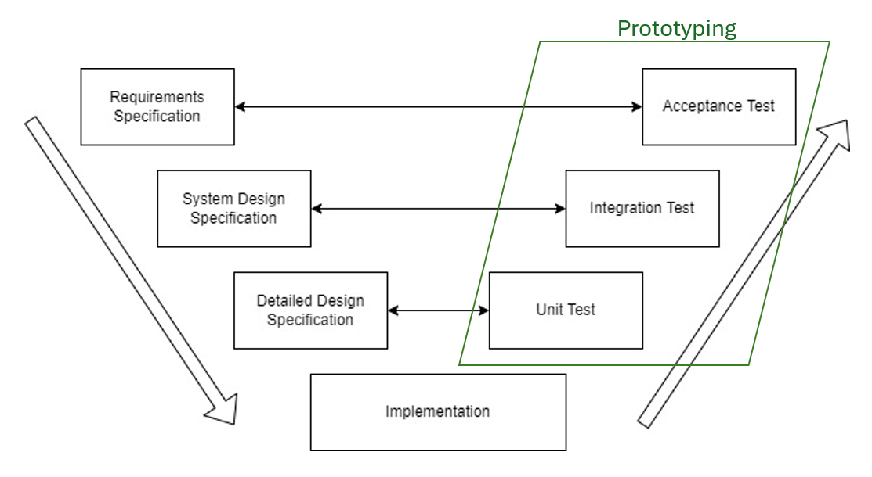

### 3.2 Project Schedule

As-built project schedule is provided in annex A.

For reference, the initial project schedule was set as the baseline in the schedule.

### 3.3 Description of changes

There are some major changes in the project schedule as the project progresses.

* The fabrication time of the end effector shortened as the same type of gripper in our design was available in the lab.
* Extra time required for the fabrication of bolt tray because of the difficulty of 3D printing.
* The unit test of software and bolt tray was performed with one module of bolt tray instead of whole module.
* The rest of the bolt tray was only fabricated after passing the unit test.
* Electrical Design was removed from the project scope because the UR5 for prototyping was pre-configured for use.
* There was idle time between 21 Oct 2024 and 7 Nov 2024 as our supervisor and company’s representative could not be reached for design review.

## System Design

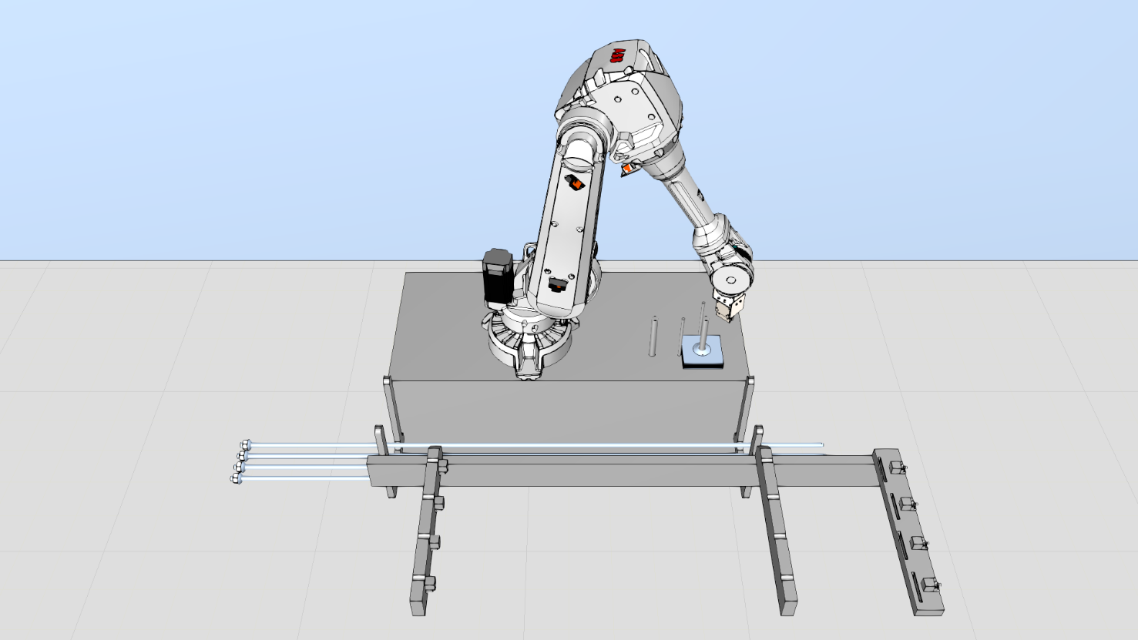

### 4.1 System Architecture

The system is composed of the following components working together to assemble the rock bolt.

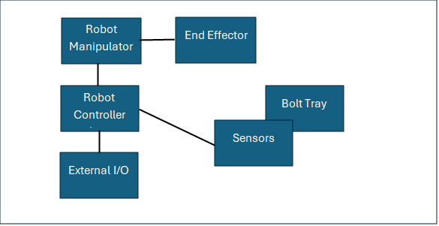

### 4.2 Components

In addition to meeting their functional requirements, all components shall operate normally under harsh environmental conditions.

#### 4.2.1 End Effector

Multi-tool end effector with magnetic gripping capabilities.

Functional requirements:

* Pick and place a rebar from the rebar stack
* Pick and place a plate from the plate stack
* Push rebar into plate

#### 4.2.2 Robot Manipulator

A 6 DOF robot manipulator to move the end effector within the workspace to perform rock bolt assembling tasks.

Functional requirements:

* Move the end effector to pick and place rebars
* Move the end effector to pick and place plates
* Move the end effector to insert rebar into the plate as part of the assembly process

#### 4.2.3 Bolt Tray

Robust structure designed to hold multiple rebars and rock bolt plates.

Functional requirements:

* Line up rebar and plate
* Hold as much as 4 assembled rebars
* Allow another mechanism (out of scope) to pick up assembled rock bolts

#### 4.2.4 Sensors

Various types of sensors to provide feedback information to the control system.

Functional requirements:

* Detect if the robot successfully picks up a rebar
* Detect if the robot successfully picks up a plate
* Detect if the robot places the rebar on the bolt tray at the right location
* Detect if the robot places the plate on the bolt tray at the right location
* Detect if the slot for the plate on the bolt tray is available
* Detect if the holder for the rebar on the bolt tray is available
* Detect if the rebar was inserted into the plate

#### 4.2.5 Robot Controller

A controller that connects to the robot.

Functional requirements:

* Motion control of robot manipulator and end effector
* Receive and process sensors’ signal
* Execute lines of code based on programme
* Manage communication between the robot and other systems

## Components Specification

### 5.1 End effector

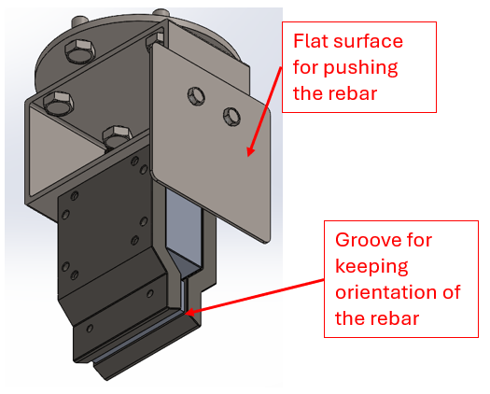

*Conceptual design drawing of the end effector*

|  |  |
| --- | --- |
| Material | 316L stainless steel |
| Dimension | 125 (L) x 100 (W) x 204.5 (H) mm |
| Operating temperature | -40 to +40°C |
| Humidity | 0 – 90% |
| IP rating | IP67 |
| Weight | 2.10kg |
| Total weight (incl. gripper) | 4.50 kg |

#### 5.1.1 Gripper

*Picture extracted from product’s brochure(2)*

|  |  |
| --- | --- |
| Model | MRP-20NK |
| Manufacturer | Ixtur |
| Type | Pneumatic Magnetic Gripper |
| Dimension | 80 (L) x 55 (W) x 114 (H) mm |
| Weight | 2.4 kg |
| Operating temperature** | 0 to +40°C |
| Humidity | 0 – 90% |
| Supplied air requirement | 6.0 bar, water separation, particle filter ≤ 5 µm |
| Gripping capacity | Flat Object: 20kg (Safety Factor 3)  Round Object: 13kg (Safety Factor 3) |
| Residual gripping capacity | 0.1kg max. |
| ** Additional heating at the end effector is required to prevent condensation forming inside the magnetic gripper and ice formation on the gripping surface when operating below freezing temperature. | |

### 5.2 Robot Manipulator

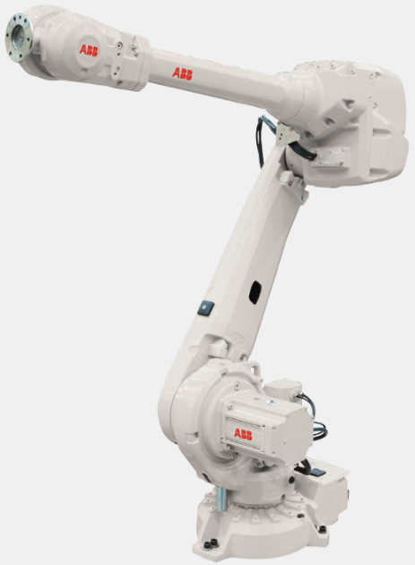

*Picture extracted from product’s brochure (6)*

|  |  |
| --- | --- |
| Model | IRB 4600-45/2.05 |
| Manufacturer | ABB |
| Reach | 2.05 m |
| Payload | 45 kg |
| Number of joints | 6 |
| IP rating | IP67 |
| Weight | 445 kg |
| Operating temperature** | 5 to 45 °C |
| Maximum humidity | 95% |
| ** Heating is required to operate in freezing temperatures. | |

### 5.3 Bolt Tray

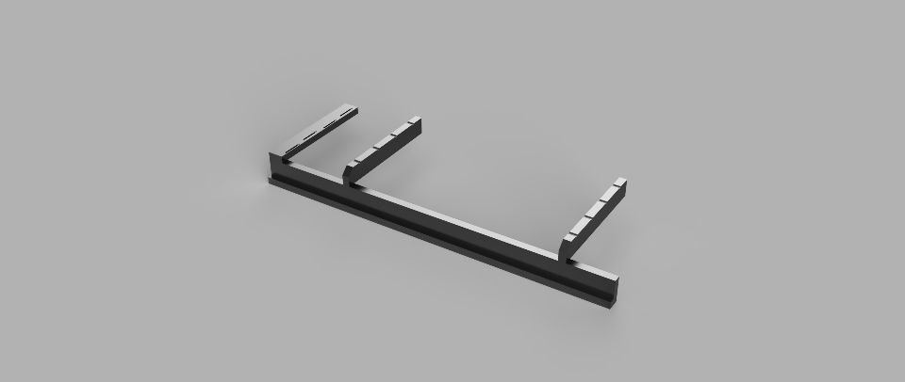

*Conceptual design drawing of the bolt tray*

|  |  |
| --- | --- |
| Material | 316L stainless steel |
| Material Density | 8 g/cm^3 |
| Bounding Box | 2475 (L) x 860 (W) x 295 (H) mm |
| Weight | 314.6kg |

### 5.4 Sensors

Inductive sensors in the tray:

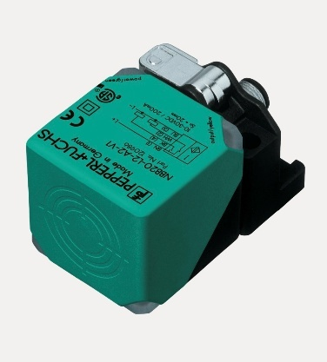

*Picture extracted from product’s brochure (8)*

|  |  |
| --- | --- |
| Model | NBN40-L2-E2-V1 |
| Manufacturer | Pepperl + Fuchs |
| Type | Inductive Sensor |
| Dimensions | 67 x 40 x 40 mm |
| Weight | 130 g |
| IP rating | IP68 / IP69K |
| Operating temperature | -25 to 85 °C |

ABB Force Control Package (13):

|  |  |
| --- | --- |
| Manufacturer | ABB |
| Type | Medium force sensor |
| Force measurement range | Fx/Fy: 660 N, Fz: 1980 N |
| Force measurement resolution | Fx/Fy: 0.09 N, Fz: 0.33 N |
| Operating temperature** | 0 to 52 °C |
| Calibration temperature** | 20 to 25 °C |
| IP rating | IP65 |
| ** Heating is required to operate in freezing temperatures. | |

### 5.5 Robot Controller

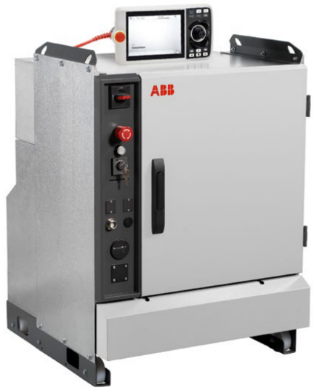

*Picture extracted from product’s brochure (7)*

|  |  |
| --- | --- |
| Model | IRC5 Single Cabinet Controller |
| Manufacturer | ABB |
| Type | Industrial Robot Controller |
| Dimensions | 970 x 725 x 710 mm |
| Weight | 150 kg |
| IP rating | IP54 (cooling ducts IP33) |
| Operating temperature** | 0 to 45 °C |
| Maximum humidity | 95% |
| ** Heating is required to operate in freezing temperatures. | |

## Simulation

### 6.1 System simulation

The simulation of the system was created using Visual Components. It is available in the project repository at

<https://github.com/Daniel-Pedraglio/ROBO.666.Robotics.Project.Work/tree/93abe78936cf79cadacaf769bc57ea32b72291ed/Design/Simulation>

### 6.2 Static Analysis of End Effector

A Von Mises Stress Test was run for the design with load on the gripper equal to 330N (3 times the weight of the rebar) in SolidWorks. From the test result, it shows that the stress levels are well below the yield strength and there is no immediate risk of failure in the operation.

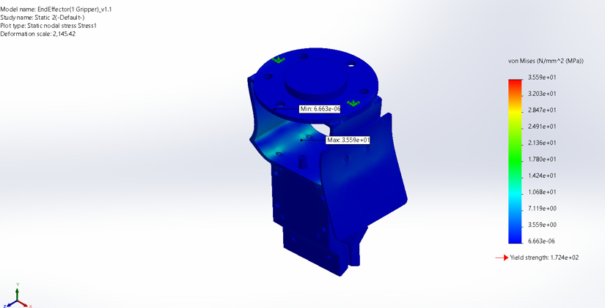

## Robot cover design concepts for harsh conditions

### 7.1 Protection against dust, mud, moisture, snow and rain

Operating in challenging industrial environments, such as construction sites or mines, exposes robots to dust, mud, and heavy rainfall. To protect the system, tailored protective covers from ARMS Robotics can be used. These covers are designed to shield the robot from dust and water while maintaining its flexibility and ensuring the joints can move smoothly without restriction.

The protective covers create a reliable barrier against fine dust particles and moisture. They have proven effective in environments like painting workshops, where particles can adhere to the robot arm's joints, dry out, and damage the articulations. This same approach is expected to protect the robot effectively in muddy and dusty industrial conditions.

Low-Temperature Robot Protective Covers (10)

To maintain the cleanliness of the surface of the gripper, a compressed air nozzle is provided within the reach of the robot manipulator so that the gripper can be cleaned by compressed air when necessary.

### 7.2 Protection against low temperature

In extremely cold conditions, like those found in outdoor industrial sites, temperatures can drop as low as –40 °C. To prevent malfunctions caused by freezing, we’re suggesting heating solutions from trusted suppliers, including VLV channel heaters (11) by Heatmasters and heating blankets by Rimatek (12).

The VLV channel heaters are compact and highly efficient, providing focused heat to prevent ice from forming on critical components, such as the gripper or joints. This is particularly important for ensuring smooth airflow in pneumatic systems, which could otherwise freeze and fail. For larger surfaces, such as the robot’s body, heating blankets offer a flexible solution to maintain consistent thermal stability.

To make these systems work seamlessly, temperature sensors can be used to monitor the environment and activate the heaters as needed. This ensures that the robot performs reliably, regardless of how harsh or freezing the conditions become.

## Prototype

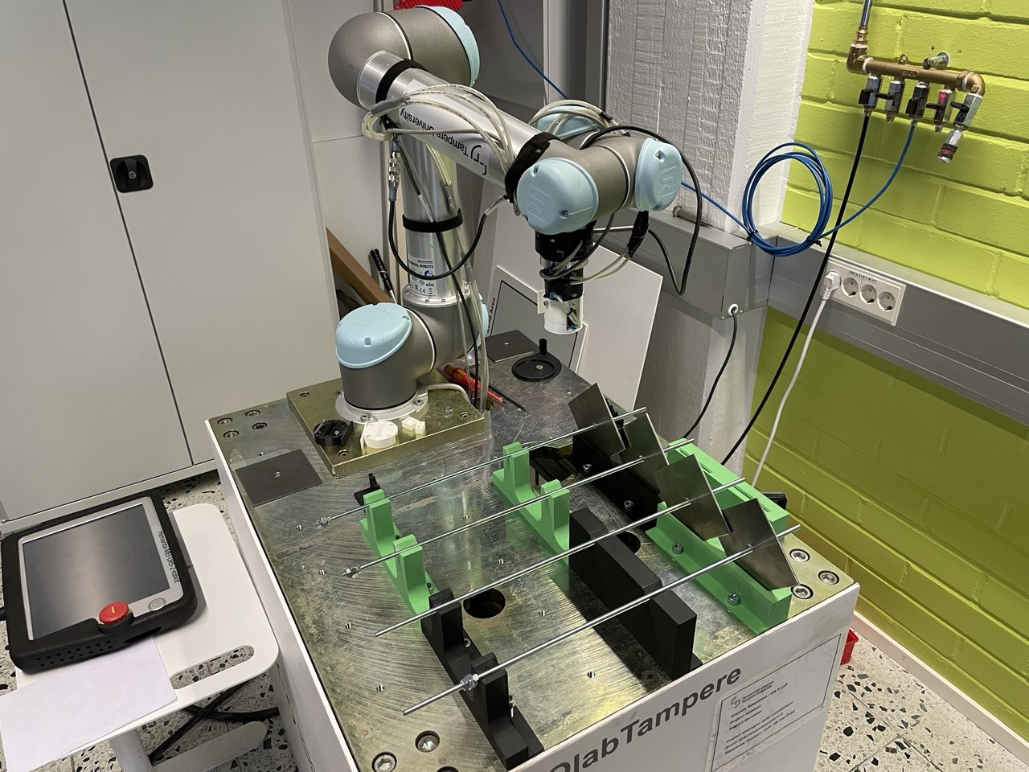

In our project, a scaled-down prototype was built to validate our design concept. Below is the specification of test materials and equipment.

### 8.1 Materials

|  |  |  |  |  |  |  |
| --- | --- | --- | --- | --- | --- | --- |
| Original | Dimensions (mm) | | Prototype | Dimensions (mm) | | Scale |
| Rebar | Diameter | ⌀25 | Screw Rod | Diameter | ⌀6 | 1:4 |
| Length | 3000 | Length | 500 | 1:6 |
| Metal Plate | Width | 200 | Metal Plate | Width | 100 | 1:2 |
| Length | 200 | Length | 100 | 1:2 |
| Thickness | 8 | Thickness | 3 | 1:3 |
| Opening | ⌀36 | Opening | ⌀9 | 1:4 |

The scale of the opening and the diameter of rebar/screw rod in original and prototype environment remains as close as 2:3.

### 8.2 End effector

A smaller pneumatic magnetic gripper (Ixtur MAP-6) was used in the end effector. As the shape of the gripper is different to the one used in the design, MRP-20NK, the end effector body was re-modelled and fabricated by 3D printing. However, the main features of the original end effector were retained, they are

1. A surface plate to push the rebar.
2. A groove to hold the orientation of rebar.
3. A surface to lift the metal plate.

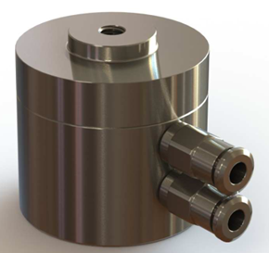

*Picture of Ixtur MAP-6 Pneumatic Magnet Gripper(5)*

*Comparison of conceptual and prototype design of end effector*

In our prototype, the end effector was able to lift metal plate and screw rod and push the screw rod into the opening of the metal plate.

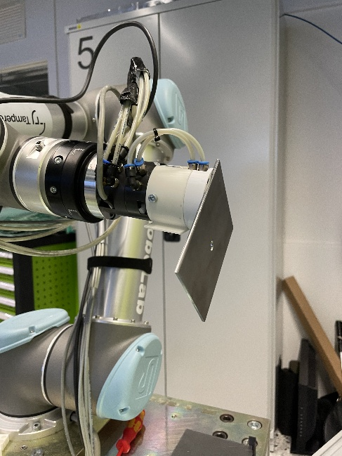 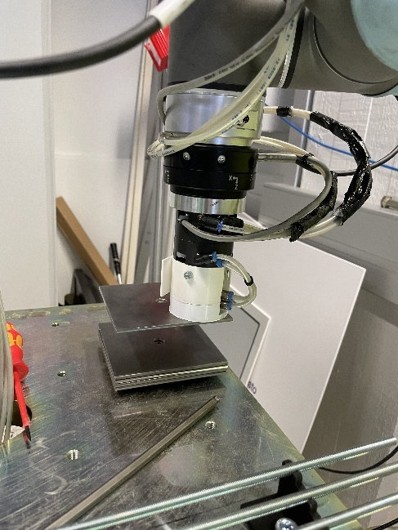

*Pictures of the end effector lifting a metal plate*

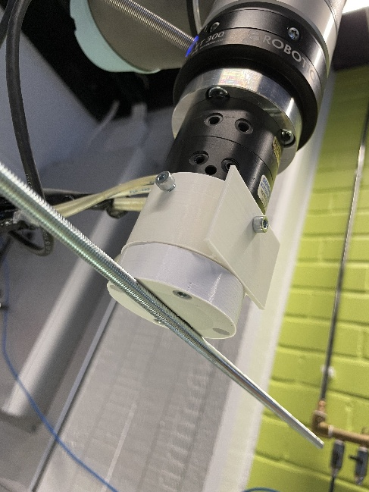 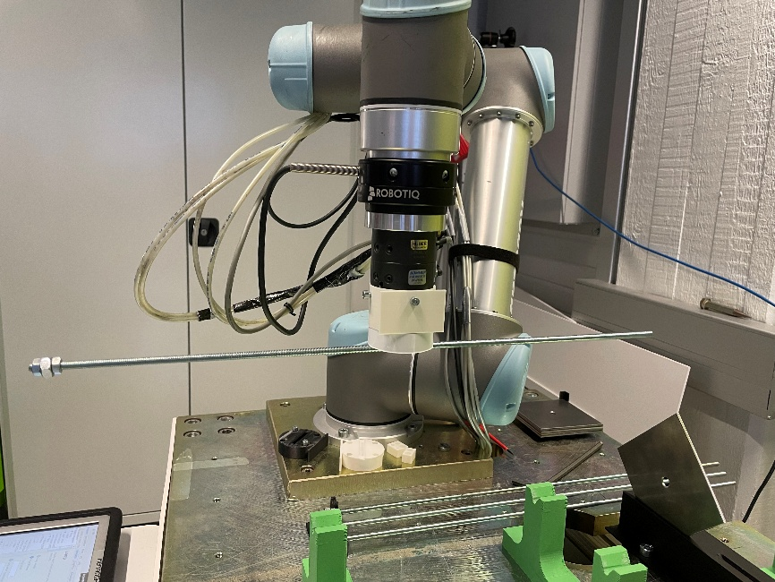

*Pictures of the end effector carrying a screw rod*

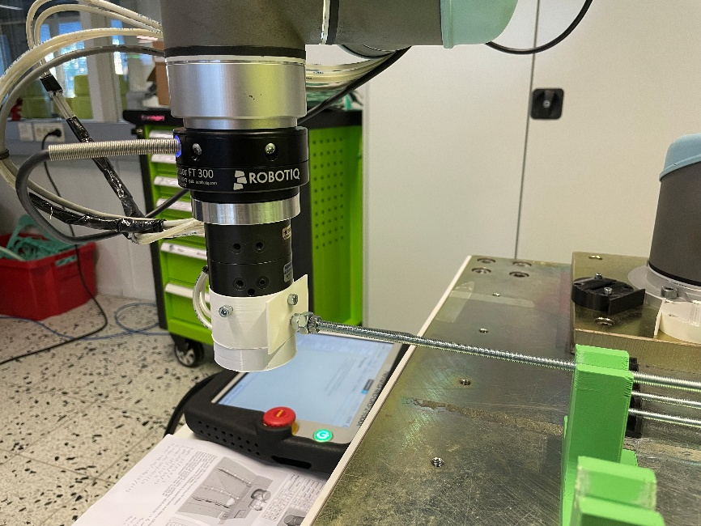

*Picture of the end effector pushing a screw rod*

Different airgaps between the gripper’s surface and metal plate were tested, they are 0.2, 0.5, 1 and 1.5mm. While the gripper managed to lift the plate securely with an airgap of 0.2 and 0.5mm, it failed to lift the plate with airgap of 1 and 1.5mm.

### 8.3 Robot Manipulator and Controller

For the robot manipulator, we were limited to the ones available at the university’s labs. The materials were scaled down to around half or a third of the original size, so the robot reach could also be lower. In RoboLab there are a few robots that fit the requirements and a UR5 was assigned to the project.

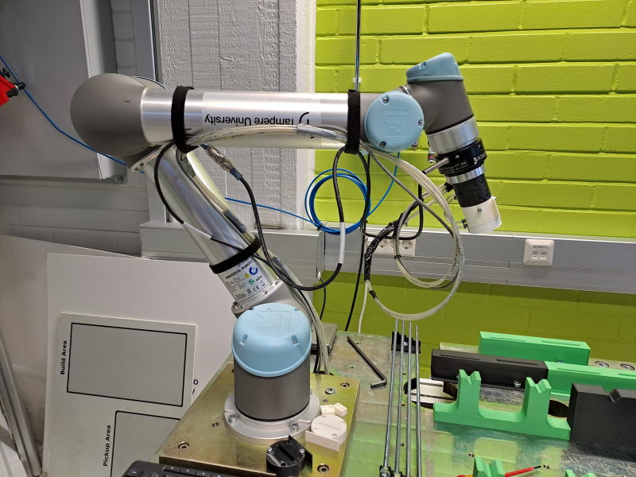

*Specifications from product’s brochure (9)*

|  |  |
| --- | --- |
| Model | UR5 |
| Manufacturer | Universal Robots |
| Reach | 0.85 m |
| Payload | 5 kg |
| Number of joints | 6 |
| IP rating | IP54 |
| Weight | 18.4 kg |
| Operating temperature | 0 to 50 °C |

The UR5 robot has the same number of joints as the ABB IRB4600. It has a lower reach and payload capacity but enough for the scaled down prototype. The IP rating and operating conditions are close, but testing in harsh conditions is not in the scope of the project. The manipulator also has a pneumatic line to be able to use the desired end effector.

The robot’s controller has 8 connections for digital outputs and 2 of them were used to activate and deactivate the magnet in the end effector. It also has a force torque sensor (FT 300 by Robotiq) which is used when pushing the rebar for more precise operation compared to the built-in force control. The robot was programmed in the PolyScope software through the teach pendant.

### 8.4 Bolt Tray

The bolt tray was designed to provide a robust and reliable platform for securely holding rebars and rock bolt plates during the assembly process. Its design incorporates critical features that ensure compatibility with the robotic manipulator and facilitate efficient assembly operations.

The bolt tray was designed using 316L stainless steel, chosen for its superior corrosion resistance, strength, and durability in industrial environments. However, for the purposes of prototyping, the tray was fabricated using PLA (Polylactic Acid) material with a Prusa 3D Printer MK4. This allowed for cost-effective and rapid iteration during the design and testing phases. PLA is derived from renewable resources like corn starch, making it eco-friendly and it has a low melting point and minimal warping, making it ideal for rapid prototyping.

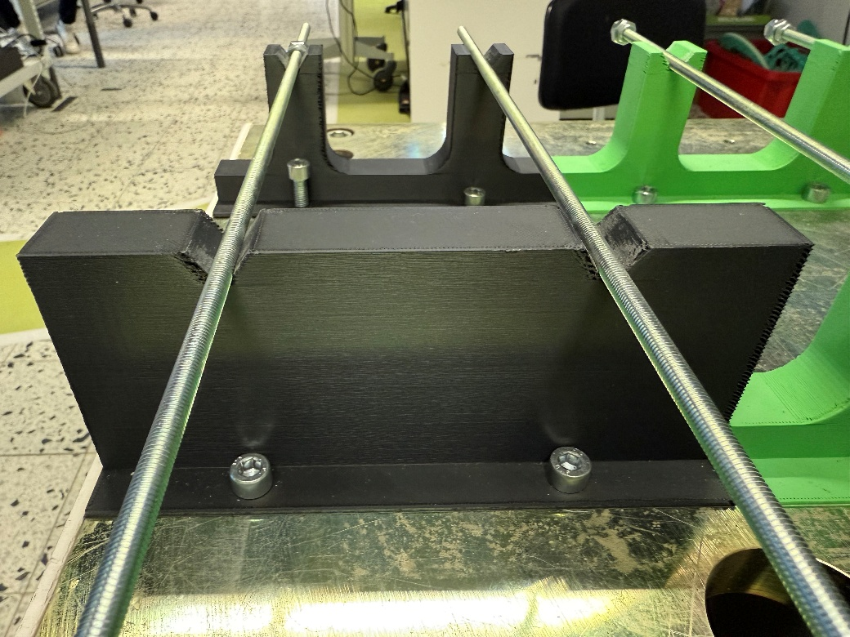

*Prototype 3D print of rebar guide*

Cutouts were made in the rebar guides to reduce print cost.

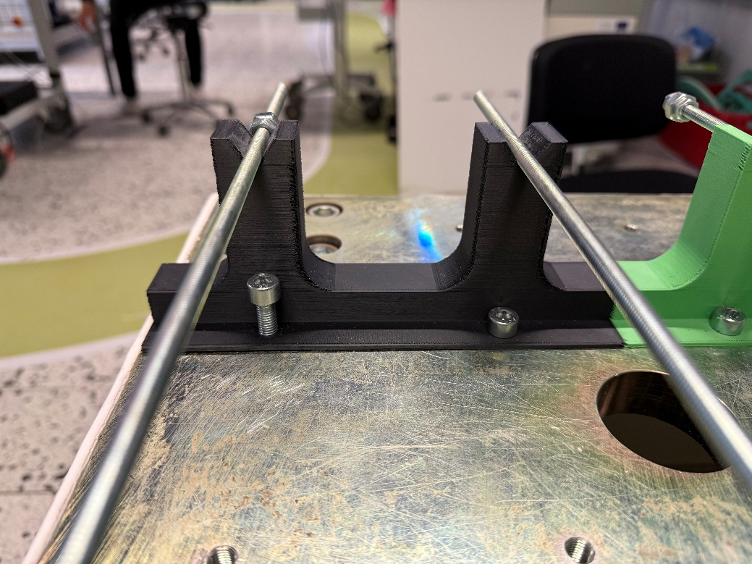

*Prototype 3D print of rebar guide with cutouts*

The connecting piece that was designed in bolt tray has been removed since the bolt tray pieces got directly bolted to the worktop that UR5 was mounted in the ROBOLAB.

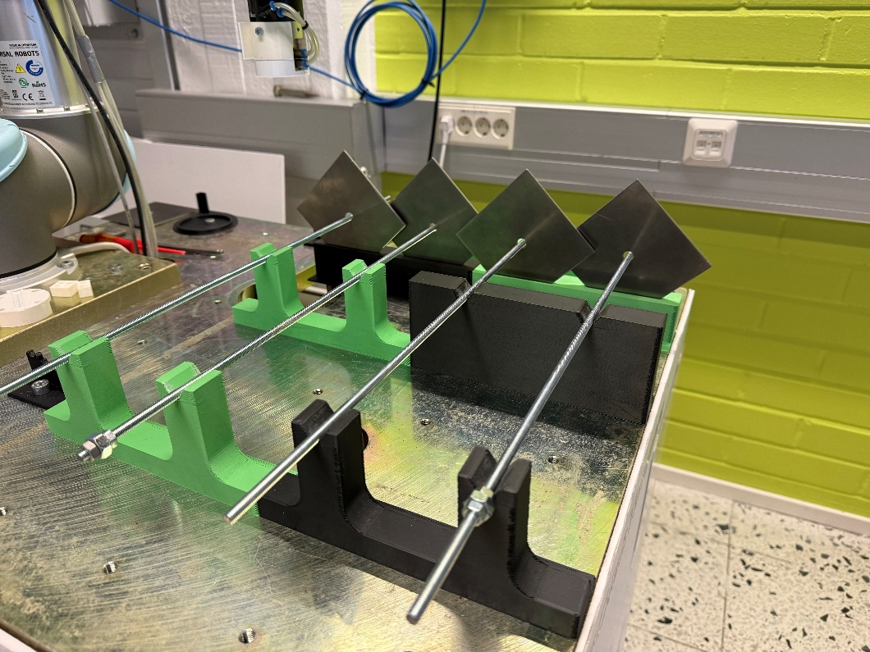

*Entire worktop view with 3D printed Bolt Tray*

### 8.5 Sensors

No inductive sensors were available for the tray in the prototype. For the robot manipulator, the FT 300 force sensor by Robotiq was used. The sensor allows the robot to limit the amount of force it uses when pushing the bars to avoid damage to the tray and detects if there is a collision before the bar is fully inserted.

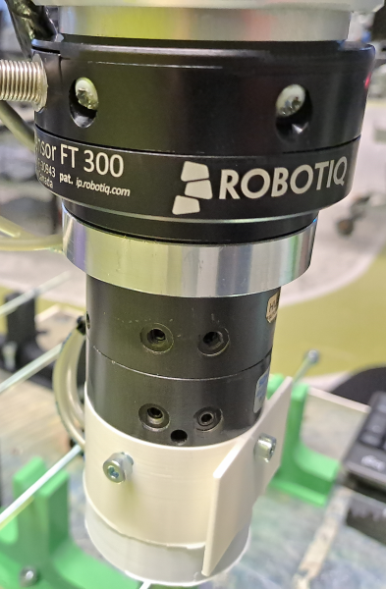

*Specifications from product’s brochure (14)*

|  |  |
| --- | --- |
| Manufacturer | Robotiq |
| Type | Force torque sensor |
| Force measurement range | ± 300 N |
| Signal noise | Fx/Fy: 1.2 N, Fz: 0.5 N |
| IP rating | IP40 |

### 8.6 Simulation

Simulation of robot movement was carried out using Visual Components to determine the location of different structures on the test table before fabrication. It is available in the project repository at

<https://github.com/Daniel-Pedraglio/ROBO.666.Robotics.Project.Work/blob/main/Prototype/Simulation/Simulation.mp4>

### 8.7 Acceptance Test Video

The full test video is available in the project repository at

<https://github.com/Daniel-Pedraglio/ROBO.666.Robotics.Project.Work/tree/93abe78936cf79cadacaf769bc57ea32b72291ed/Prototype/Media>

## Discussion

### 9.1 End Effector

During testing with the scaled-down prototype, it showed that the design of the end effector is capable of satisfying its functional requirements.

The chosen model of the magnetic gripper has an IP67 rating (1), ensuring it is dust-tight and protected against temporary immersion of water(4). The rest of the end effector body is made of 316L stainless steel which provides resistance to corrosion and wear in wet or dusty conditions.

In addition, the minimum operation temperature of the pneumatic magnetic gripper is limited to the temperature of supplied compressed air. Below freezing temperature, water condensation in the compressed airline results in formation of ice, causing corrosion inside the gripper over time. However, consultation with Sandvik confirmed that the supplied compressed air from the machine side will meet the gripper’s dryness specification and remains above 0oC. Additionally, to prevent formation of ice on the gripper surface, heating shall be provided to the end effector.

One of the environmental conditions is constant vibration of up to 1G from nearby machinery. While this model of the gripper lacks vibration test data, pneumatic magnet grippers manufactured by SMC are capable of withstanding impact of 15G and operating in vibration environment of up to 3G(3).

In the case of gripper handling rebar or metal plate with dust, dirt or other foreign objects on the surface of the materials, the gripper is sized to allow an air gap of 0.25mm for picking the rebar and over 0.5mm for picking the metal plate(2). As shown in our prototype test, the air gap between the surface of gripper and material has a significant effect on the gripping capacity. Depending on the real environment, the exact required magnetic force might need to be recalculated, and specification increased to fulfil the requirement.

One concern during the design phase was the gripper lifting multiple plates from the stack. However, the above scenario did not materialise during testing with the prototype.

### 9.2 Robot Manipulator

When searching for robot manipulators, it became clear that none of them would be able to handle the harsh conditions’ temperature range. As such, it stopped being a criterion. A heating system would be required.

The 2 main factors left to consider when selecting the robot manipulator were reach and payload. The farthest positions the robot has to reach are the plate holder and the end of the rebars to push them. A reach of 1920 mm was considered enough. For payload, it must be able to carry the rebar and end-effector's weight up to the last tray slot, estimated at 15.5 kg at 1155 mm.

The prototype validated the simulation’s motion but also showed some issues with fast movements. Rapid rotation had to be avoided as much as possible while holding the plate vertically due to possible slipping of the plate caused by moment of weight. Linear motion mixed with rotation also had to be slowed down or separated because of high joint speed near their limits.

The sensors included in the proposal allow the robot to know if something went wrong during the assembly process. Some actions, like picking up or pushing the rebar can be reattempted. In other cases, the robot would stop, and a message would be sent to the operator for them to fix it. As an improvement, a depth sensor or camera could be added to allow the robot to fix some errors and make remote operation easier.

### 9.3 Bolt Tray

The bolt tray prototype was fabricated using PLA material with a Prusa 3D Printer MK4. While the 3D printing process provided a quick and cost-effective way to produce the prototype, some challenges were encountered due to the default nozzle size of the printer. The nozzle produced imperfections in the printed bolt tray, especially around finer features like grooves and cutouts. These imperfections required manual filing and post-processing to ensure the tray met the required tolerances and could perform as intended. After these adjustments, the bolt tray worked without any further issues during laboratory testing.

However, it is important to note that the testing environment in the lab differed significantly from the extreme conditions the bolt tray is designed to endure in industrial applications.

Specifically:

* Temperature Extremes: The lab environment could not simulate extreme cold conditions, such as temperatures as low as -40°C, where material brittleness and thermal expansion could become issues.
* Dust and Mud: The bolt tray was not exposed to muddy or dusty conditions typical of actual field operations. These elements could interfere with the alignment grooves or lead to material degradation over time.
* Dynamic Loads: The prototype was not subjected to heavy, repetitive dynamic loads that would occur in real-world applications, making it difficult to assess long-term durability.

Mud Collection in Cutouts:

A potential issue identified during the design phase is the accumulation of mud or debris in the alignment grooves and cutouts of the bolt tray. This could hinder the proper placement of rebars and rock bolt plates by the robotic system. To address this issue, a solution was proposed to integrate a separate pneumatic line into the robot’s end effector. The pressurized air from this line could be directed to blow debris out of the cutouts in the bolt tray, ensuring the grooves remain clear for proper alignment. This modification would enhance the reliability of the system in harsh conditions without requiring manual cleaning.

Material Considerations for Final Design:

While the PLA prototype was effective for validating the bolt tray’s conceptual design and functionality, 316L stainless steel remains the material of choice for the final implementation. Its superior strength, corrosion resistance, and ability to withstand extreme temperatures make it well-suited for industrial applications. Moreover, the final stainless-steel version would not face the same challenges with imperfections and structural weaknesses as the PLA prototype.

### 9.4 Sensors

Only the force sensor was available for the prototype. It was useful to detect when a bar hit the plate instead of going through. The robot would then stop instead of breaking the plate holder. Other sensors were not integrated into the prototype due to resource constraints, but their inclusion in the final design would significantly enhance the bolt tray's functionality and reliability in real-world applications. Sensors provide critical feedback to the control system. Sensors should detect whether the robot has correctly placed the rebar and rock bolt plates on the bolt tray. This feedback prevents errors during the assembly process by enabling the system to halt operations if any misalignment or incorrect placement is detected, allowing for immediate correction before proceeding.

## Conclusion

In the end, we were able to fulfil all project goals set by Sandvik within the allowed timeframe and budget.

A rock bolt assembling robot system for harsh conditions was designed. Specification of system and components were provided with available equipment in the market.

The assembling mechanism was validated and verified with a scaled down prototype in RoboLab.

Design and feasible solution of protecting the robot system against harsh conditions was proposed and included in the report.

## Future works

* Test the robot system in real extreme weather conditions.
* Incorporate safety measures according to Machine Directives and other related ISO standards.
* Introduce Machine Vision System using 3D depth camera to locate rebar in stack and align the rebar with the opening of the plate.

## Role of group member

Kin Tung

* Project management
* System design
* Design end effector
* Design and build end effector prototype

Eren Pekgöz

* Tray design
* Sensor proposal
* Design and build tray prototype
* Harsh conditions proposals

Daniel Pedraglio O'Hara

* Robot manipulator selection
* Simulation of full scale and prototype
* Programming of prototype

## Reflection

Kin Tung

This project gave me a valuable opportunity to learn how to use 3D printing for prototyping while I freshened up my modelling skill with SolidWorks. I also had a chance to work with a real robot manipulator. I learnt about the harsh environmental conditions in the mining industry currently facing.

V-model was chosen to be the development life cycle model. In my opinion, it was a good decision because we were required to validate our design concept through prototyping. V model allows redesigning individual components in case of a test failure without causing significant delays to the entire project.

There were some challenges in the initial phase of motion planning because of the gripping point of metal plate and the characteristic of magnetic gripper. Because of the smoothness of the metal plate, we had to restrict the rotation speed to prevent the plate from sliding off the gripper while being held vertically.

Eren Pekgöz

This project was a great opportunity to refine my CAD skills and gain hands-on experience in industrial design. My main responsibility was developing the bolt tray, a key component in the rock bolt assembly process. Using Autodesk Fusion, I created detailed 3D models and refined iterations, refreshing my CAD skills since my bachelor's studies.

A major challenge was ensuring proper alignment of rebars and plates while keeping the tray durable and manufacturable. The PLA 3D-printed prototype had nozzle-related imperfections that required manual corrections.

I also selected the appropriate sensor by comparing brands and models to ensure accuracy and environmental resistance. Researching protective covers and heating elements gave me insight into maintaining safe operating conditions in harsh environments.

Overall, this project improved my design skills and understanding of real-world constraints. Seeing our prototype function as intended was rewarding, and there’s still potential for further sensor integration and testing in extreme conditions.

Daniel Pedraglio O'Hara

This project was my first experience working with an actual robot. I learned about simulation in Visual Components and then its implementation in the Polyscope software used by the UR5 robot. The simulations were useful to check the reach and limb positions during movement, as the target positions can be reached in several ways but some lead to the robot crashing into the environment.

For the prototype, the robot was programmed directly in the teach pendant. Visual Components has an export tool, but it struggled with the variable positions needed to handle the 4 plates and rebars. The version of Polyscope provided by the manufacturer is newer than the one in the robot as well, so I avoided any offline simulations there. I would have also been missing the addon for the force sensor. But in the end, even if working with the teach pendant was slow, it allowed us to change things right there and keep testing. Thanks to the prototype, we found some issues that did not exist in the simulation, like the plate sliding off due to fast movement or the cables near the end effector getting in the way during operation.

## Project Repository

<https://github.com/Daniel-Pedraglio/ROBO.666.Robotics.Project.Work.git>

## References

1. MRP-20NK Technical Specifications and Instructions, Ixtur

<https://www.ixtur.com/wp-content/uploads/2023/08/MRP-20NK_product-_instructions_27042022.pdf>

1. MRP-20NK Brochure, Ixtur

<https://www.ixtur.com/wp-content/uploads/2023/08/Brochure_MRP-20NK_ENG112018.pdf>

1. Magnet Gripper Unit for Collaborative Robots MHM-25D-X7400A-ASSISTA(-P) Operation Manual, SMC Corporation

<https://www.smcworld.com/assets/manual/en-jp/files/MHx-OMY0019.pdf>

1. Ingress Protection (IP) ratings, IEC

<https://www.iec.ch/ip-ratings>

1. MAP-6 Pneumatic Magnet brochure, Ixtur

<https://www.ixtur.com/wp-content/uploads/2023/08/Brochure_MAP-6-40_ENG_112018.pdf>

1. IRB 4600 Datasheet, ABB

<https://library.e.abb.com/public/5d09cebd840c446ba337c85541523aa7/IRB4600_Datasheet_20231207.pdf>

1. IRC5 Controller, ABB

<https://library.e.abb.com/public/a5da3469d8a3441abc64b1d9941a04d7/datasheet_IRC5_20230328.pdf>

1. Inductive sensor NBN40-L2-E2-V1

<https://files.pepperl-fuchs.com/webcat/navi/productInfo/pds/187484_eng.pdf?v=20250112020052>

1. UR5 Technical Specifications, Universal Robots

<https://www.universal-robots.com/media/50588/ur5_en.pdf>

1. Low Temperature Robot Protective Covers

<https://www.armsrobots.com/sale-36764816-low-temperature-robot-protective-covers-clothing-resistant-for-abb-robot-arm.html>

1. VLV Heating Elements

<https://heatmasters.net/product/heating-elements/>

1. Rimatek Custom Made Heating Blankets

<https://www.rimatek.com/en/custom-heating-blankets/>

1. Force Control Package, ABB

<https://search.abb.com/library/Download.aspx?DocumentID=3HAC091307-001&LanguageCode=en&DocumentPartId=&Action=Launch>

1. FT 300 Force Torque Sensor, Robotiq

<https://blog.robotiq.com/hubfs/support-files/Copilot_Instruction_Manual_20210308.pdf>

## Annex A: As-built Project Schedule